Guided Capstone Project Report

*Executive Summary*

Executives at Big Mountain Resort are trying to understand whether a price increase can be absorbed by its market. Additionally, it is looking for guidance on asset use including adding lift capacity and / or closing one or more runs.

This report will recommend that Big Mountain increase Weekend Adult Tickets by $8.00 to $89. Additionally, it should close one run as this will have little impact on customer demand and add one ski lift. The cost reduction and revenue increase should more than cover the $1.5 million in increased costs and will make the resort more attractive

*Introduction and Context*

Big Mountain Resort is trying to understand what pricing flexibility it has relative to resorts around the continental United States. Resorts around the country have varied facilities and varied terrains and elevations that skiers enjoy using. Currently Big Mountain Resort, located in Montana, has a base elevation of 4,464’, a summit elevation of 6,817’, and a vertical drop of 2,353’. It is in a top-5 state for both skiable area and resort density.

It’s price point at $81 for an adult weekend ticket is higher than the national average of $64.28 and the Montana average of $51.91. However, it has great facilities including several fast quad lifts. See details of Big Mountain Below:

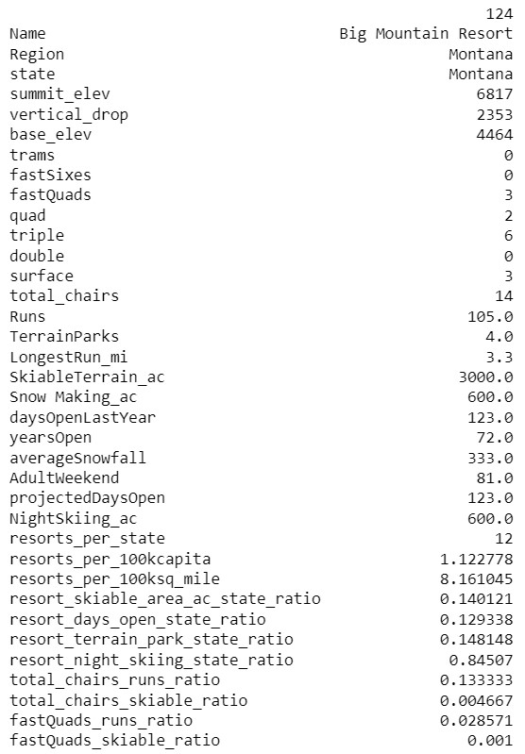

*Available Data*

Two data sources were used. One containing details of ski resorts around the country including resort name, state, and features of the resort such as skiable area, lift capacity, and snow making capability. The other provided state level information including area of the state, population, and other demographic information. The data was combined into a single table and cleansed. Although Big Mountain Resort had a complete data set, not all of the other resorts had complete data sets. To this end, several columns and rows of data were deleted including AdultWeekday pricing, fastEight lift column. Several rows were dropped including one resort whose length of opening could not be determined. Additionally, resorts with no pricing data were dropped. Several data were corrected by going to the source of the data including SkiableTerrain_ac. Ultimately, we will be using the available variables to model AdultWeekend Pricing.

*Exploratory Analysis*

A preliminary assessment of the data was performed using principal components analysis (PCA), which is a technique used to “simplify” the data. This analysis suggests that, in terms of explanatory variables that are useful in modeling AdultWeekend pricing and these include vertical_drop (vertical drop), Snow Making_AC (snow making acreage), Runs (number of runs), fastQuads (number of fast quad lifts), total_chairs (total number of chairs), and resort_night_skiing_state_ratio (a derived value that looks at the ratio of night skiing area to total skiing area). A heat map of these relationships can be found below and note that the lighter the color the more correlated the relationship:

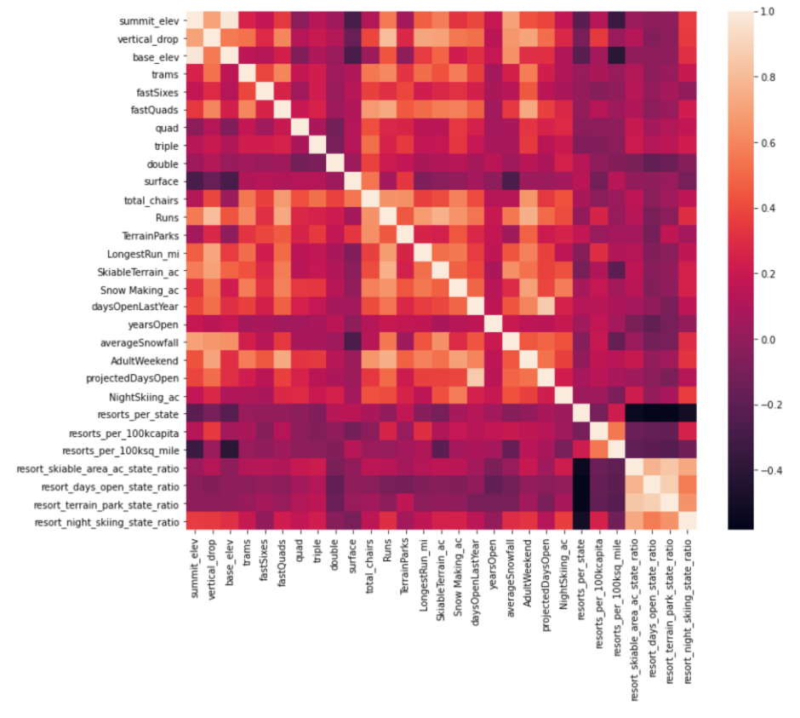

*Preprocessing, Training, and Modeling*

First, we tested whether just using the mean of the data would provide sufficient predictive power without extensive modeling. We confirmed that modeling the price data would be useful. Second, missing data for parameters was imputed by using the median of the data (although there wasn’t much of a difference in the final result between the mean or the median). Second, we scaled the data around its mean and standard deviation. Training was performed on both a linear regression model and on a random forest regressor. For the linear regression model the explanatory variables and their coefficients are:

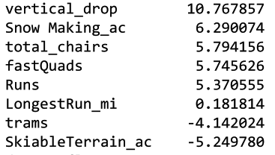

Said another way: AdultWeekend (Price We can Charge) = 10.77vertical_drop + 6.29Snow Making_ac + 5.79total_chairs + 5.75fastQuads + 5.37Runs + 0.18LongestRun_mi – 4.14Trams – 5.25SkiableTerrain_ac for their normalized values. While the random forest regressor doesn’t have such a succinct equation, the important parameters in its model are essentially the same.

*Modeling Scenarios and Recommendation*

Assume 350k visitors and the following scenarios

1. Examine closing up to 10 of the least used runs (Closing 1 run has no impact on ticket price while all others have negative impact)
2. Increase the vertical drop by 150’ but require an additional lift to bring customers back up (Can increase ticket price by $8.61 generating ~$15 million)
3. Same as 2 but add two acres of snow making cover (not recommended as it has nearly no impact versus 2 and with extra cost)
4. Increase the longest run by 0.2 miles to 3.5 miles and add 4 acres of snow cover. (not recommended, no impact on pricing)

Based on these scenarios we should increase the price by $8, close one of the least used runs and increase the vertical drop by 150’ without adding snow making.